Camera Shot Style

1. Extreme Close Up Shot - small area or detail of the subject, such as the eye(s) or mouth.
2. Choker Shot - above the eyebrows to below the mouth
3. Close-Up Shot - Fills the screen with part of the subject, such as a person’s head/face.
4. Medium Close-Up - chest or shoulder up.
5. Medium Shot - waist up.
6. Cowboy Shot - mid-thighs up
7. Medium Long Shot or Medium Wide Shot - Shows subject from the knees up.
8. Full Shot - Head to toe, with the subject roughly filling the frame. The emphasis tends to be more on action.
9. Long Shot or Wide Shot - Shows the subject from top to bottom. Though not necessarily filling the frame.
10. Extreme Long Shot or Extreme Wide Shot - Show the subject from a distance. Useful for establishing a scene.
11. Establishing Shot - Often used at the beginning of a video, the establishing shot is a wider angle of view that gives context to the subject.

Camera Angle

1. Ground Level Shot - captures what is in the frame at ground level, that is, the feet, or maybe the character lying on the ground.
2. Knee Level Shot -
3. Hip-level shot - Film the subject from waist or hip level to draw focus to that area of the subject's body.
4. Shoulder Level Shot - camera angle that is as high as your subject’s shoulders.
5. Eye Level - neutral effect on the audience.
6. High Angle - photographed from above eye level. Effect of making the subject seem vulnerable, weak, or frightened.
7. Overhead shot - An overhead shot is from above, looking down on your subject. These are typically shot from 90 degrees above.
8. Crane Shot
9. Aerial Shot - The highest camera angle is the aerial view.
10. Low Angle - photographed from below eye level. This can have the effect of making the subject look powerful, heroic, or dangerous.
11. Dutch Angle/Tilt - Shot in which the camera is set at an angle on its roll axis so that the horizon line is not level.
12. Over-the-Shoulder Shot - A popular shot where a subject is shot from behind the shoulder of another.
13. Point of view shot - that is shot as if through the eyes of a character. The camera shows what the subject's eyes would see.

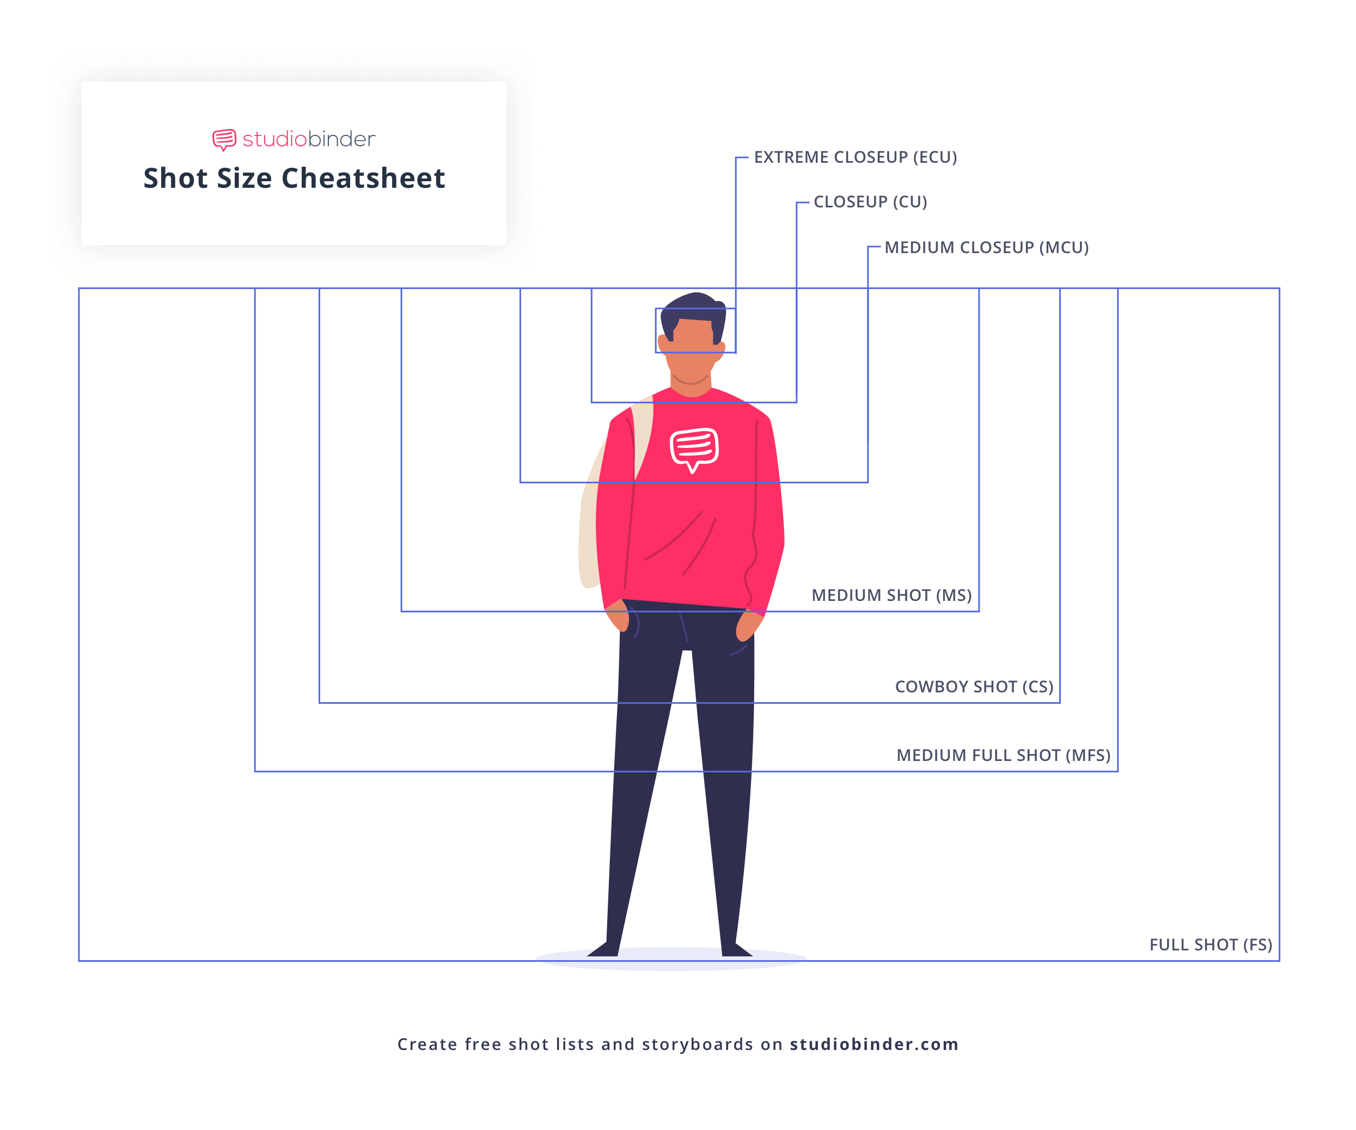

Over-the-shoulder shot - The over-the-shoulder shot is a camera angle used in film and television, where the camera is placed above the back of the shoulder and head of a subject. This shot is most commonly used to present conversational back and forth between two subjects.

**The medium shot** - It's similar to the cowboy shot above, but frames from roughly the waist up and through the torso. it focuses on a character (or characters) in a scene while still showing some environment.

**Medium Close-Up** - Falls between a Medium Shot and a Close-Up, generally framing the subject from chest or shoulder up.

**Close-Up Shot** - Close-Up Fills the screen with part of the subject, such as a person’s head/face. Framed this tightly, the emotions and reaction of a character dominate the scene.

**Choker** - A variant of a Close-Up, this shot frames the subject’s face from above the eyebrows to below the mouth

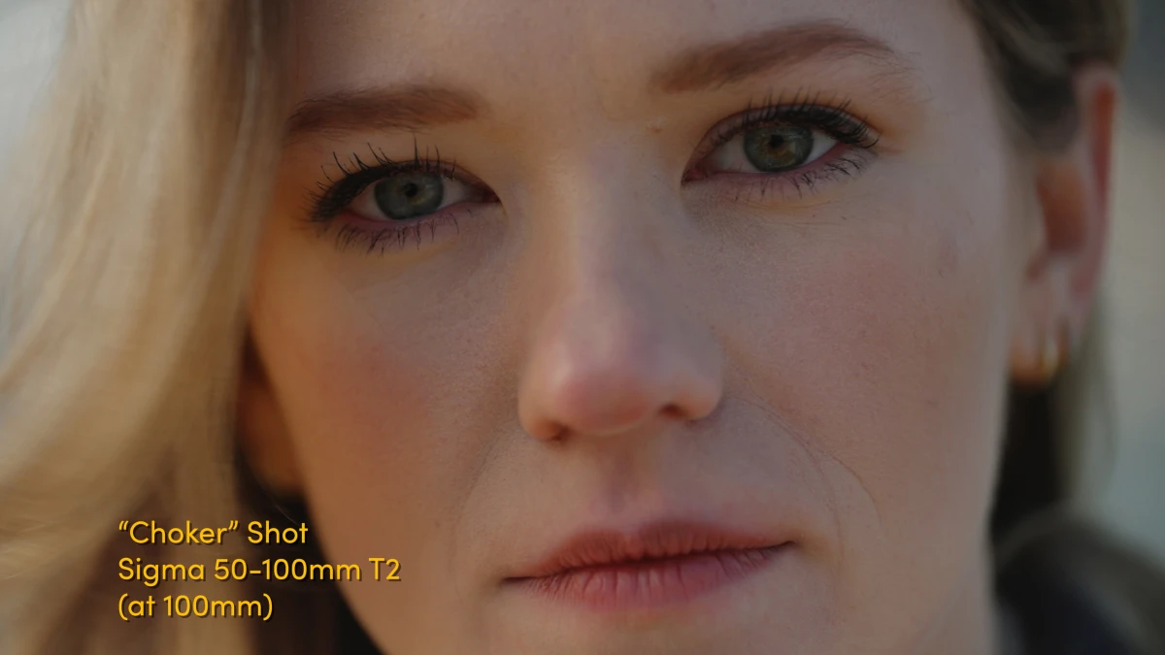

**Extreme Close Up** - Emphasizes a small area or detail of the subject, such as the eye(s) or mouth. An Extreme Close Up of just the eyes is sometimes called an Italian Shot, getting its name from Sergio Leone’s Italian-Western films that popularized it.

